CUPE 5678 Swag from Ignite Printing, Brockville

It is the responsibility of the member ordering to determine size.
Specify when ordering if want full back CUPE logo imprint when applicable.
There will be no returns/refunds/changes permitted due to incorrect size.
Please call Ignite Printing 613-865-7494 if you need assistance with your size before ordering.

Price includes Taxes

CUPE 5678 Branded Hooded Sweatshirt CUPE logo imprint on left chest and optional full back
Link for colour and sizing Hooded sweatshirt 2500
$40

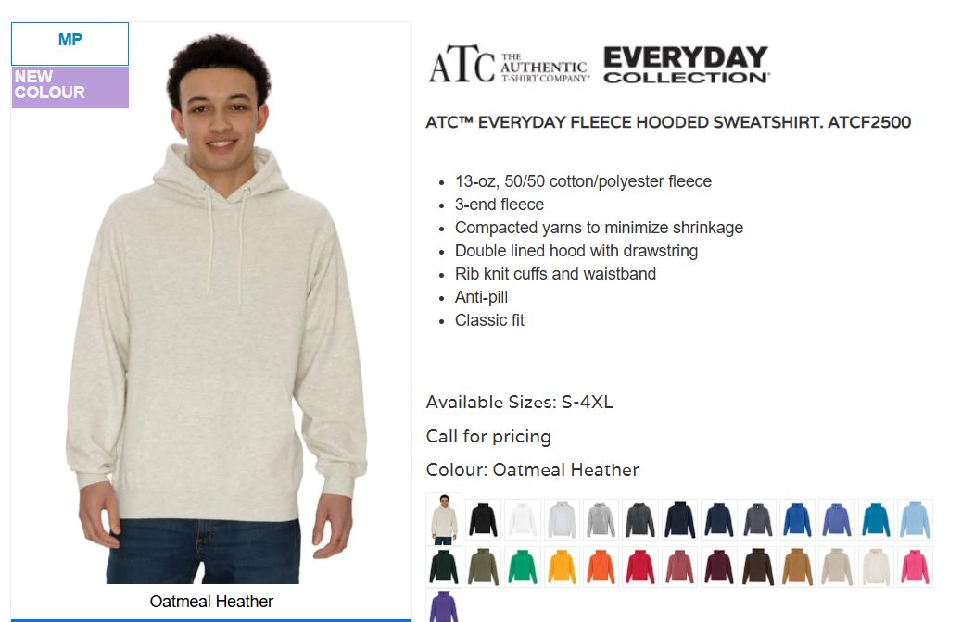

CUPE 5678 Pre Washed Hooded Sweatshirt CUPE logo imprint on left chest and optional full back
Link for colour and sizing Pullover Pre Washed Hooded Sweatshirt 7270
$84

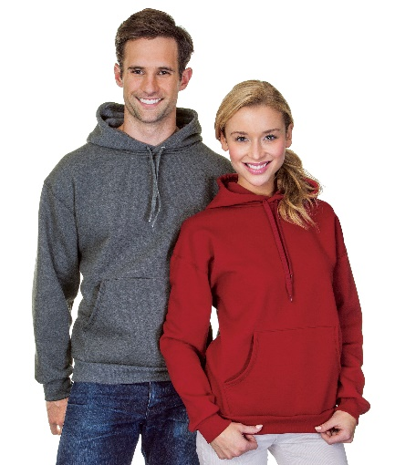

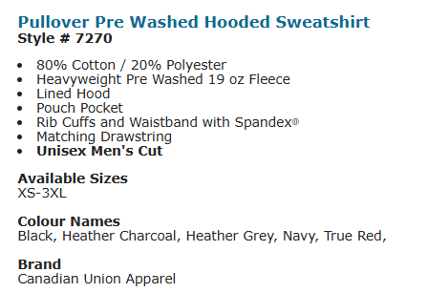

CUPE 5678 Branded Fleece Joggers (back pocket zipper) CUPE 5678 logo imprint on left leg
Link for colour and sizing Joggers 2850
$45

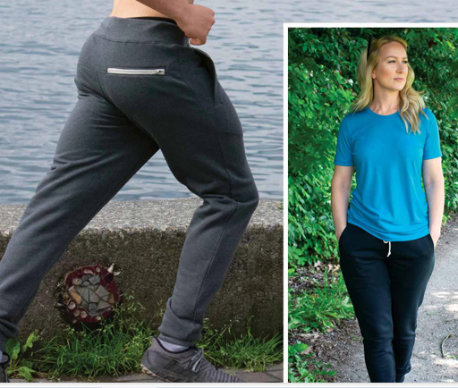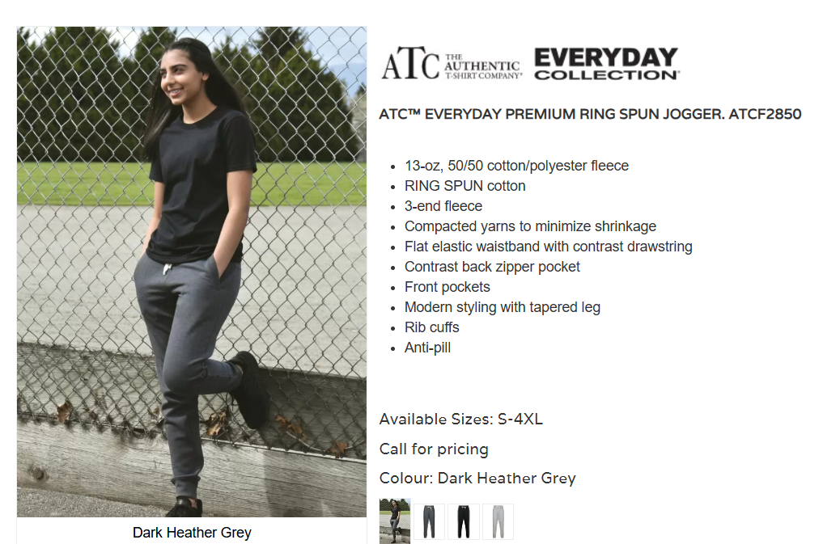

CUPE 5678 Branded Everyday Fleece Sweatpants ( NO back pocket zipper)
CUPE 5678 logo imprint on left leg Link for colour and sizing EVERYDAY FLEECE SWEATPANTS 2800
$45

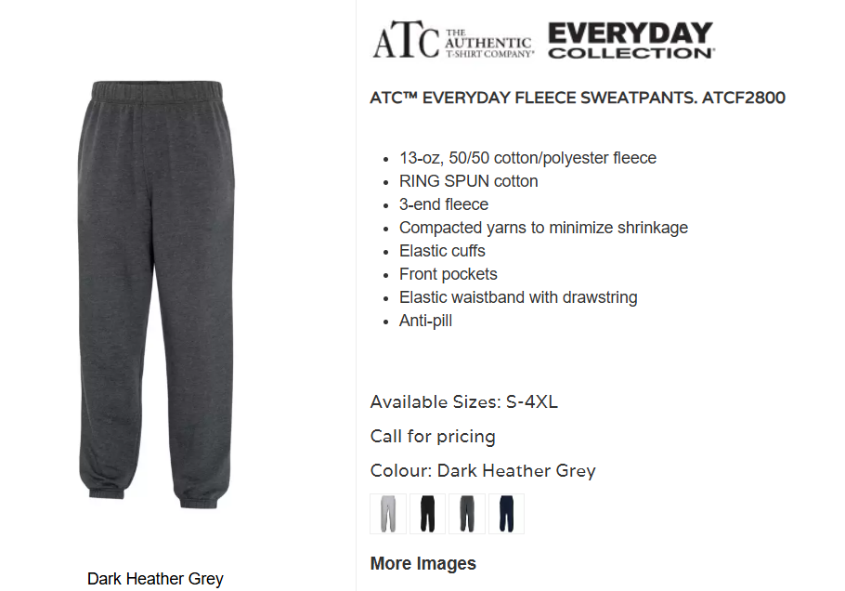

CUPE 5678 Classic Fit Heavyweight Cotton T-Shirt CUPE logo imprint on left chest and optional full back
Link for colour and sizing Classic Fit Heavyweight Cotton T-Shirt 2000
$32

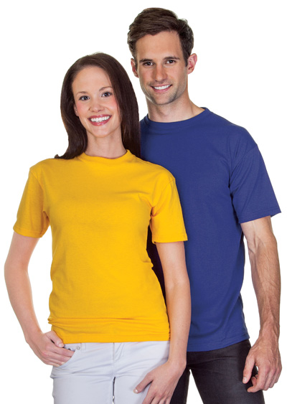
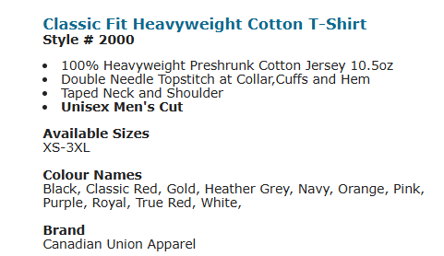

CUPE 5678 Classic Fit Heavyweight Cotton Long Sleeve T-Shirt
CUPE logo imprint on left chest and optional full back
Link for colour and sizing Classic Fit Heavyweight Cotton Long Sleeve T-Shirt 2005
$44

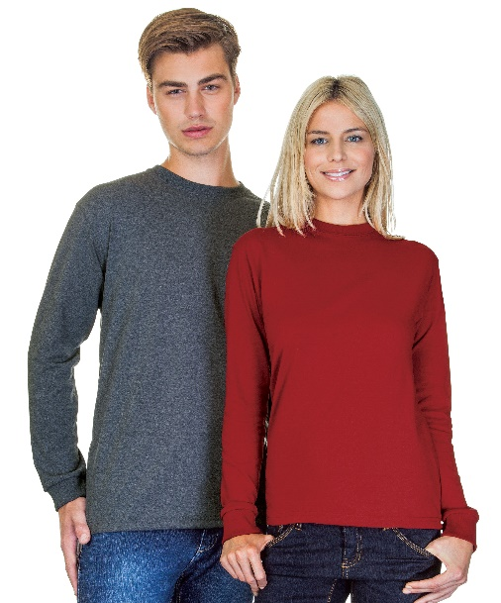

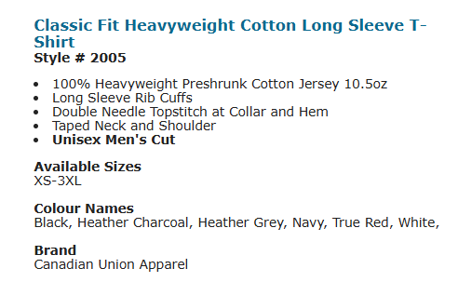

CUPE 5678 Coal Harbour Everyday Snag Resistant Polo S365 with left chest imprint
Link to view & sizing options Coal Harbour Everyday Snag Resistant Polo S365
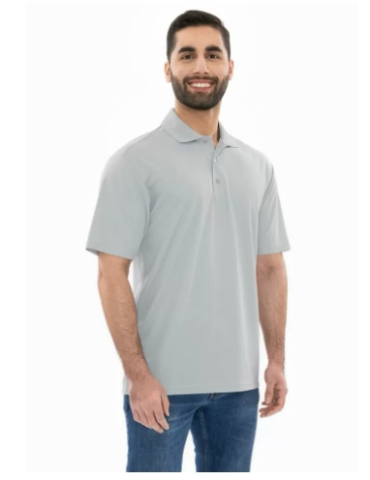
$35

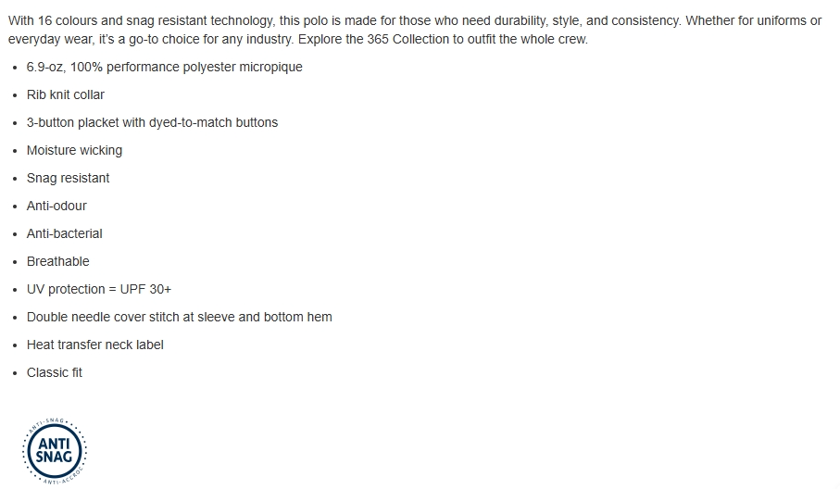

CUPE 5678 Coal Harbour Everyday Snag Resistant LADIES Polo S365 with left chest imprint
Link to view & sizing options Coal Harbour Everyday Snag Resistant LADIES Polo S365
$35
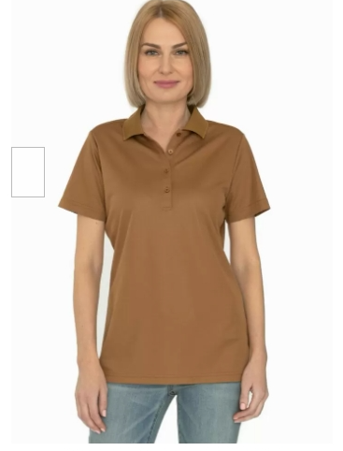

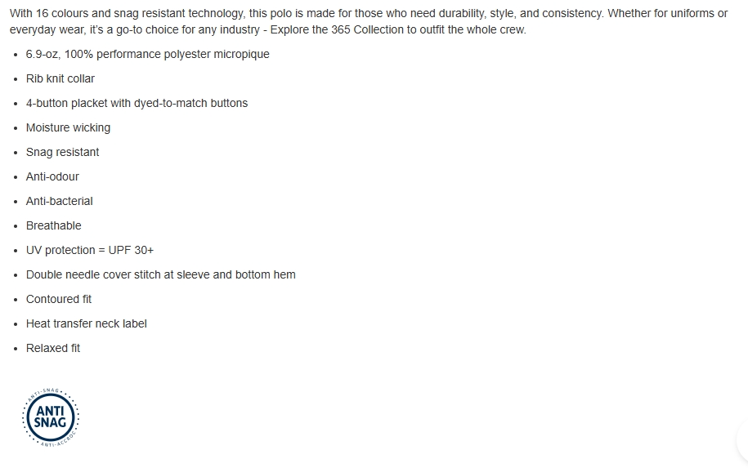

CUPE 5678 Canadian Union Apparel Polo Shirt with left chest imprint
Link to view & sizing options Canadian Union Apparel Mens Polo shirt
$65.00

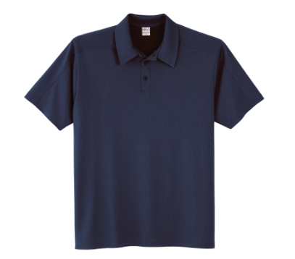
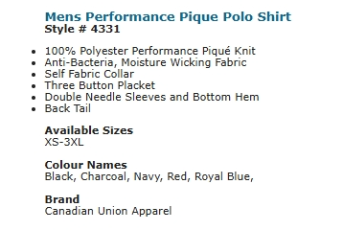

CUPE 5678 Canadian Union Apparel LADIES Polo shirt with left chest imprint
Link to view & sizing options Canadian Union Apparel Ladies Polo shirt

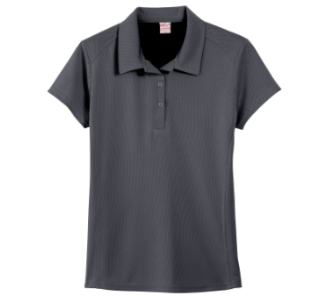
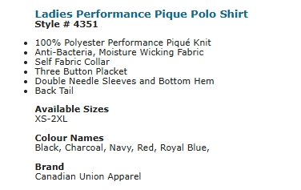

CUPE 5678 Full Zip Black Fleece Jacket w/Left chest and optional full back logo digital imprint
Link to view & sizing options Full Zip Black Fleece jacket 2010
$55

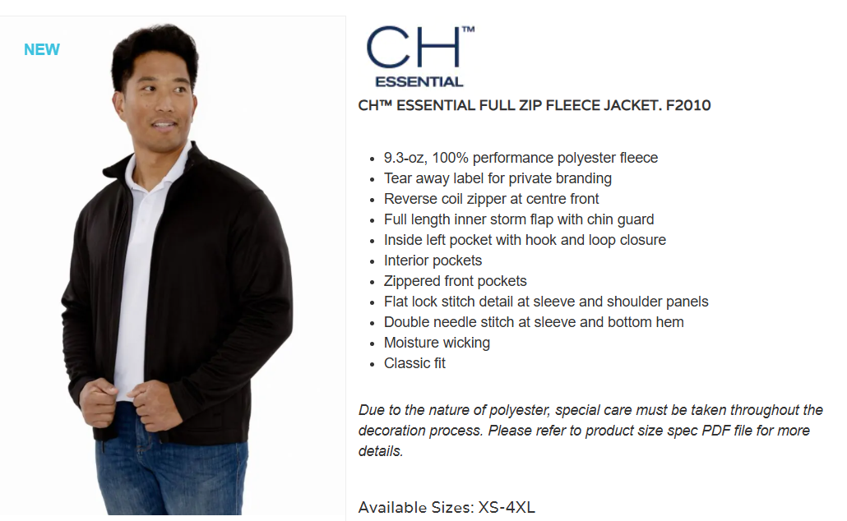

CUPE 5678 Full Zip Water Repellent Jacket w/Left chest and optional full back logo digital imprint
Link to view colour & sizing options Full zip water repellant jacket 7603
$70
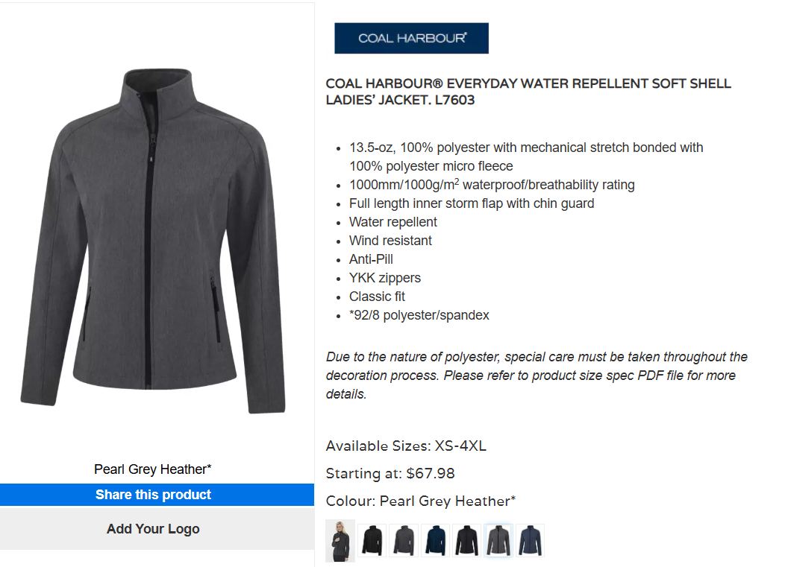

CUPE 5678 17oz Stainless Steel Bottle White Stainless Steel Bottle w/sublimation logo CUPE 5678
$26
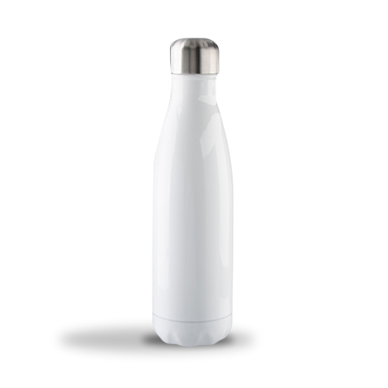

CUPE 5678 Branded Pen & Notepad
Spiral Notebook Size 8.5 x 11" 50 Pages
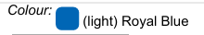
$17

