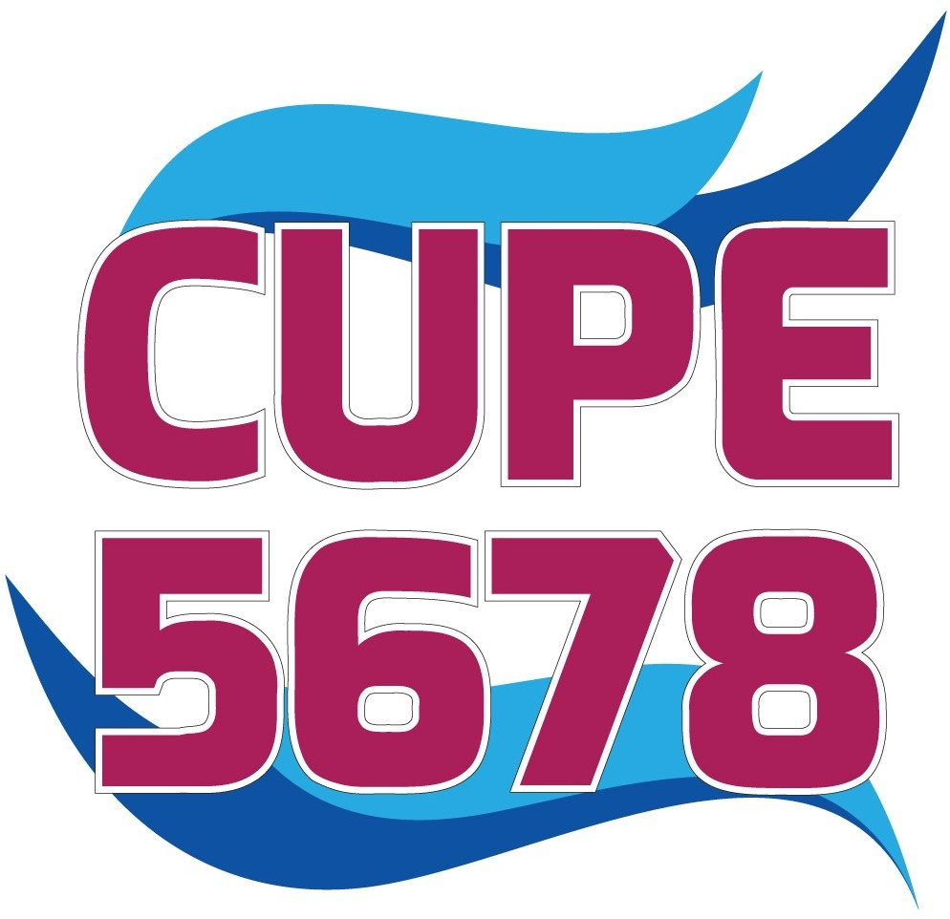**AGENDA**

**General Membership Meeting Saturday, October 26th, 2024 10:00 a.m. to 12:00 p.m.**

**In Person- Seaway District High School 2 Beach Street, Iroquois, ON K0E 1K0**

**Virtual-TEAMS Meeting** : email will be sent to CUPE emails. When you register for the meeting, you will receive an email *“You’re registered for Membership/Special Membership*

*Meeting”* Click on the link to join.

1. Acknowledgment of Indigenous territory
2. Roll call of officers
3. Reading of the Equality Statement
4. Voting on new members and initiation
5. Reading of the minutes
6. Matters arising from the minutes
7. Secretary-Treasurer’s Report
   * August 15th, 2024 Audit
8. Communications and bills
9. Executive Committee Report
10. Reports of committees and delegates
11. Nominations, elections, or installations
12. Unfinished business
13. New business
    * Election Candidates - 2 minute speech (must be registered to speak by October 24th to [returning.officer@cupe5678.ca](mailto:returning.officer@cupe5678.ca) so a speakers list can be prepared)
14. Good of the Union
    * Membership Engagement Draw $1,900.00 (Must be in attendance)
    * Member in Attendance Draw $100.00
15. Adjournment