If you are having difficulty setting up your CUPE email, please email [info@cupe5678.ca](mailto:info@cupe5678.ca) or call the CUPE office 613-342-0434 / 1-877-342-CUPE(2873)

Your email address is [firstname.lastname@cupe5678.ca](mailto:firstname.lastname@cupe5678.ca)

If you had a previous CUPE email set up on your phone or an iPad, you will need to delete it from that device before you try to follow these instructions. **If you checked your email via a web browser, there is no account to delete.**

We have a new email provider, thus the set up and accessing CUPE email is now different and needs to be set up. Passwords were sent to personal emails on file. If you do not have this, you need to request a password reset (either when you are trying to sign in or by contacting info@cupe5678.ca with a personal email address) before proceeding.

If you are getting a CUPE email for the first time (you did not have a previous CUPE email) you will need to complete and submit the form found on our website [www.cupe5678.ca](http://www.cupe5678.ca)



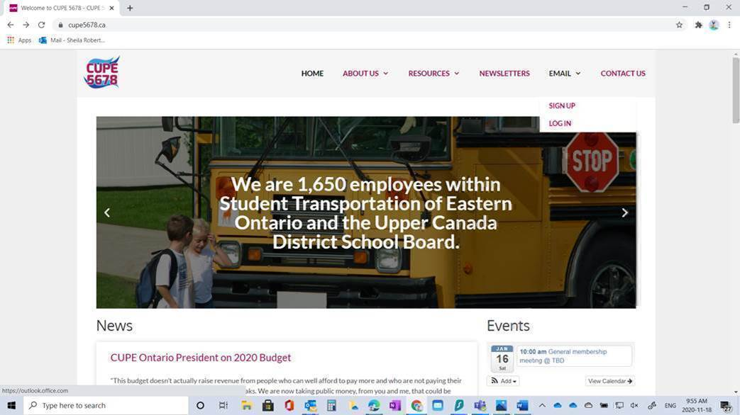

**Instructions are for setting up the CUPE email on Outlook**.

If you are trying to set up your CUPE email using your UCDSB device, this will not work for you as it is the employer Microsoft Office Account and has restrictions.

Open Outlook

Click on File

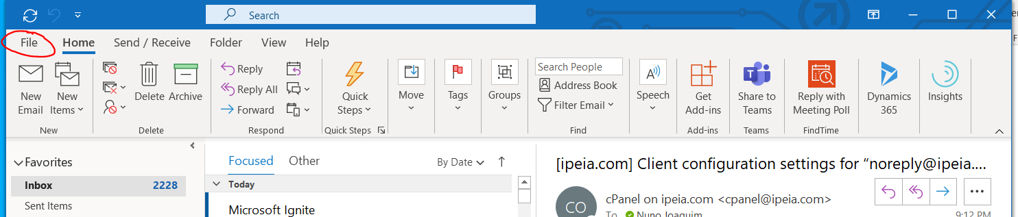

Click Add Account

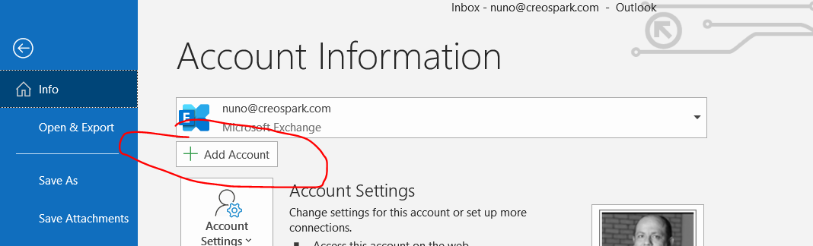

Enter Your email address and click Connect

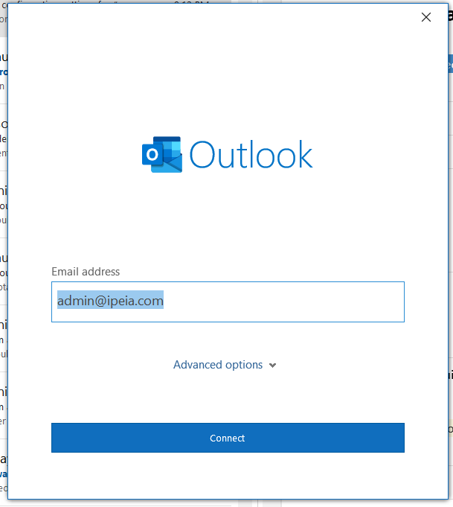

Select Microsoft 365

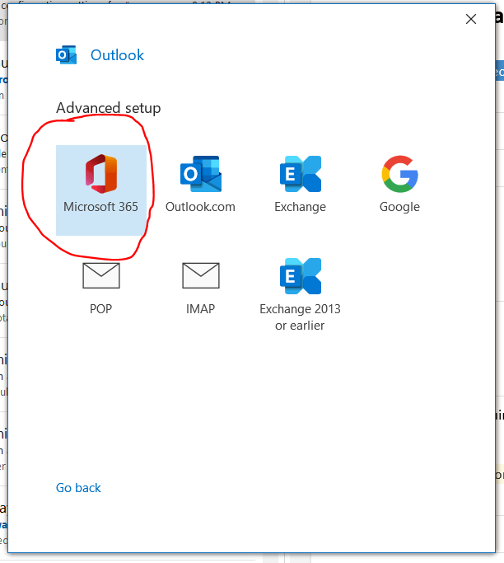

Enter your email address again

Enter your password

**You can also log into your CUPE email at** [**www.office.com**](http://www.office.com)**.**

However, if you are on your UCDSB device, you will need to do this in a new window / incognito because the device is your UCDSB device.

Depending on your browser, it will look like this when you open a web browser.

An Ink Drawing
 With Ink Annotations

An Ink Drawing
 With Ink Annotations

**If you are setting up the CUPE email on your phone:**

**If you are using the outlook app**



On the left hand side, there is an envelop with a plus sign / Add email account and select Office 365 if required.

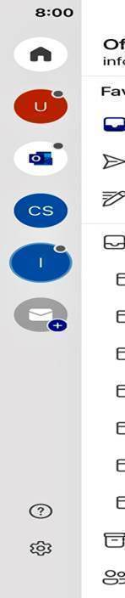

**If you are using the default mail app on your phone**

 Settings > MAIL > Accounts >ADD ACCOUNT

You will need to select Microsoft Exchange